Greek Life Participation Edgar Vazquez EECS 372 Spring 2015 Professor Uriel Wilensky
Bacground
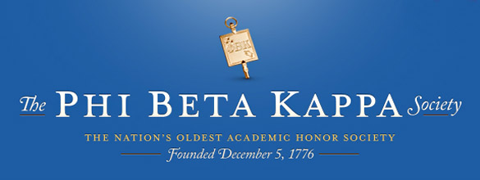
Big picture overview Begining with Phi Beta Kappa, the first Greek lettered fraternal organization in the United States, for almost two and half centuries, fraternities and sororities have continued to make their presence at man of the universities and colleges across the United States. Each year, the thousands of incoming students get involved in the different extracurricular activities available at their school. Among those activities is Greek lettered fraternities and sororities. Being an activity unique to colleges and universities, participation in these organizations varies from school to school. Participation can range from eighty-four percent as it’s reported at Welch College to zero percent as is the participation at Amherst College. These percentages are influenced by a number of factors but perhaps one that can reach a wider range of students and even students that are yet to attend a college or university is the media. Generally speaking, the Greek system has been and continues to be no stranger to mostly negative publicity by media outlets. Whether it’s hazing new members, alcohol abuse, sexual misconduct, etc., fraternities and sororities more often than not are the center of attention of many media outlets for negative conduct. This spring semester alone, one hundred and thirty-three fraternities and sororities faced disciplinary action at different colleges and universities for the previously mentioned activities.
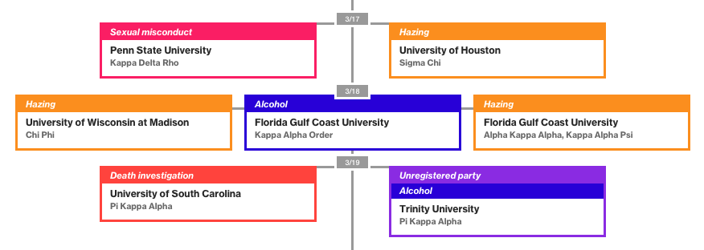
Greek organizations across the United States and their offenses.
Now while the Greek system does get scrutinized often for its flaws, it also gets media recognition for the community service hours committed by members as well as money raised for philanthropies, albeit not often. This media attention nonetheless reaches a portion of the college student body. With all the positive and negative media attention, one cannot help but wonder how recruitment is affected by this coverage.
Learning Potential
This model attempts to demonstrate how media coverage surrounding an event that is directly related to a Greek organization affects the overall opinion of students towards Greek life and how this in turn affects participation in Greek life. The model attempts to give insight into:
- How Greek life participation can be maintained despite negative media influence;
- How Greek life participation can be eliminated with negative media influence;
- How Greek life participation can take over a campus with positive media influence;
- How Greek life participation is affected by competing groups (Greek and anti-Greek); and
- How Greek life can shift with positive and negative media coverage at different intervals;
Although not the primary focus of the model, another discussion point pertains to the layout of the world and how it could affect Greek lie participation.
Motivation
Being a member of Greek life myself, one of the first things I learned about recruitment is that people join other people. Observing interactions between any groups of students can confirm this. People with similar interests become friends and many times, like myself, members of the same Greek organization. When joining any organization, a strong association between the individual and the organization is inevitable, whether it be by the individual or outsiders. This association can carry a lot of weight which can bring positive or negative consequences. Thinking again of the media coverage, the media is efficient in creating stigmas and negative perspectives on a plethora of topics. Unfortunately, Greek life is not safe from the perspective that media outlets create for it and often this perspective becomes a dominant one. Such a perspective can be used to make generalizations about Greek life and through association, its participants. If negative enough, may drive potential members away from it and may convince present members to disassociate themselves from it. On the contrary, if positive enough, it may drive an increase in Greek life participation. In the real world it is rare that a campus becomes all Greek or all anti-Greek. Some schools, however, have eliminated Greek life from their extracurricular activities. For example, Amherst College recently banned students from joining Greek organizations due to negative media coverage that they received for being accused about the sexually hostile climate propagated by fraternities. Northwestern has had its share of scandals surrounding Greek life yet it still witnesses participation from forty percent of its student body.
Rationale
Agent based modeling streamlines student interactions as Netlogo allows for many interactions to occur between agents at once. Individual interactions are necessary to make the model more realistic with respect to how students on a real campus interact with each other. NetLogo also streamlines random movement while still allowing for controlled movement. This is necessary to allow turtles to roam randomly in the world and more realistically represent how students move around campus. Controlled movement is needed to move turtles to a Greek building to simulate how a new Greek member would spend a portion of his or her time at their organization’s house shortly after joining. In addition to control over individual turtles, agent based modeling, and NetLogo, allows for different parameters to be tested in conjunction or individually. Testing individual parameters and controlling others allows for a robust analysis to be done on the parameters. Being able to do this can aid in exploring why and how the model’s outcomes occur.

Model Implementation
Implementation
Code
Setup Procedures
The 3 setup procedures do the same thing except they draw different building layouts. In each setup, all global and agent level variables are set.
On any of the setup procedures:
- Clear everything
- Set the rush? variable to 0*
- Set the new-year? Variable to 1*
- Set the rush counter, positive event tick counter, and negative event tick counter to 0
- Set turtle shape to “person”
- Create the number of turtle agents determined by the POPULATION slider variable
  - Place them in random places around the world
  - Assign turtles as Greeks based on the PERCENT-GREEK slider variable
  - Assign turtles that aren’t Greek as antiGreek based on PROBABILITY-OF-ANTIGREEK slider
  - Assign a year to each turtle (one of 1 2 3 or 4)
  - If Greek, set BIAS to 10
  - If antiGreek set BIAS to -10
  - If neither Greek or antiGreek set BIAS to 0
  - Color the turtles based on their year
  - Color the turtles based on whether they are Greek or antiGreek
- Create boundaries for buildings
- Color patches where Greek house will be
Go Procedures
The first few procedures in the code are used for the rush period.*
The procedures following it check to see if the turtle is in a Greek building, move the turtles, have them interact with each other, and check if they’ve met the threshold to be Greek or antiGreek.
On each tick:
- Check if it’s a new year (is new-year? = 1)
  - If it is, check if the rush period has begun
    - If it has, move towards a Greek patch if I’m Greek and ticks are under 175 (as determined by the rush tick counter)
    - If the rush tick counter is greater than 175, walk around randomly again, end rush period (change the rush? Variable to 0), change new-year? to 0
  - Otherwise continue onto the next procedure
- Check if negative events are set and if the negative event counter has reached the value set by the slider
  - If so, go to negative event procedure and update bias
  - If school influence is being used, update bias again
- Check if positive events are set and if the positive event counter has reached the value set by the slider
  - If so, go to positive event procedure and update bias
  - If school influence is being used, update bias again
- Check if I am on a Greek patch (indicating I’m in a Greek building)
  - If I am, update my bias
- Check patch-ahead
  - If it’s yellow, turn a random degree out of 360
  - If it’s not yellow, turn left random out of 90 and then turn right random out of 90 then move forward
- Interact with other turtles
  - Set one of the turtles in my radius (3) as my turtle to interact with
    - If they’re Greek and I’m Greek change my bias by multiplying theirs by .0025 and adding it to mine
    - If they’re Greek and I’m not Greek and they’re older (they’re year > my year) and my year is no higher than 2 change my bias by multiplying theirs by .0015 and adding it to mine
    - If they’re Greek and I’m not Greek and they’re not older (they’re year <= my year) or my year is higher than 2 change my bias by multiplying theirs by .0001 and adding it to mine
    - If they’re anti-Greek and I’m anti-Greek change my bias by multiplying theirs by .0025 and adding it to mine
    - If they’re anti-Greek and I’m not anti-Greek and they’re older (they’re year > my year) and my year is no higher than 2 change my bias by multiplying theirs by .0015 and adding it to mine
    - If they’re anti-Greek and I’m not anti-Greek and they’re not older (they’re year <= my year) or my year is higher than 2 change my bias by multiplying theirs by .0001 and adding it to mine
    - If they’re neither Greek or anti-Greek don’t change my bias
- Check if the tick count is at 400
  - If it is, start a new year (set new-year? to1)
  - Update the year of each turtle
Interface
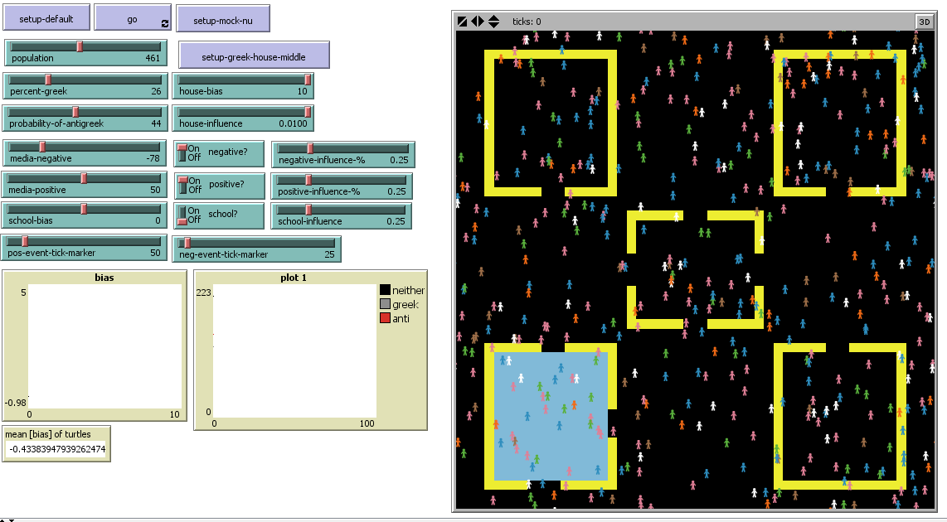
The interface is divided into two sections, the parameter space (left) and the world output (right).
Setup There are three setups to choose from. SETUP-DEFAULT and SETUP-GREEK-HOUSE-MIDDLE are the same setup with respect to buildings, the only difference being that the Greek house is in the middle for SETUP-GREEK-HOUSE-MIDDLE and on the bottom right for SETUP-DEFAULT. These setups should be on a 50 max-pxcor by 50 max-pycor world space.
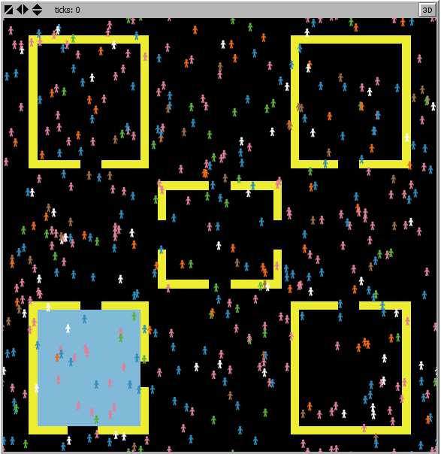
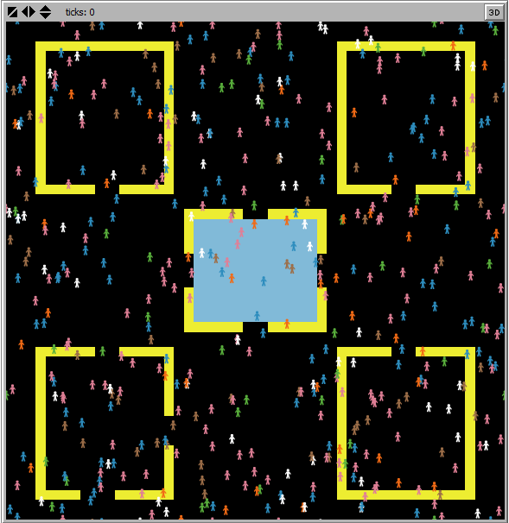

SETUP-DEFAULT SETUP-GREEK-HOUSE-MIDDLE
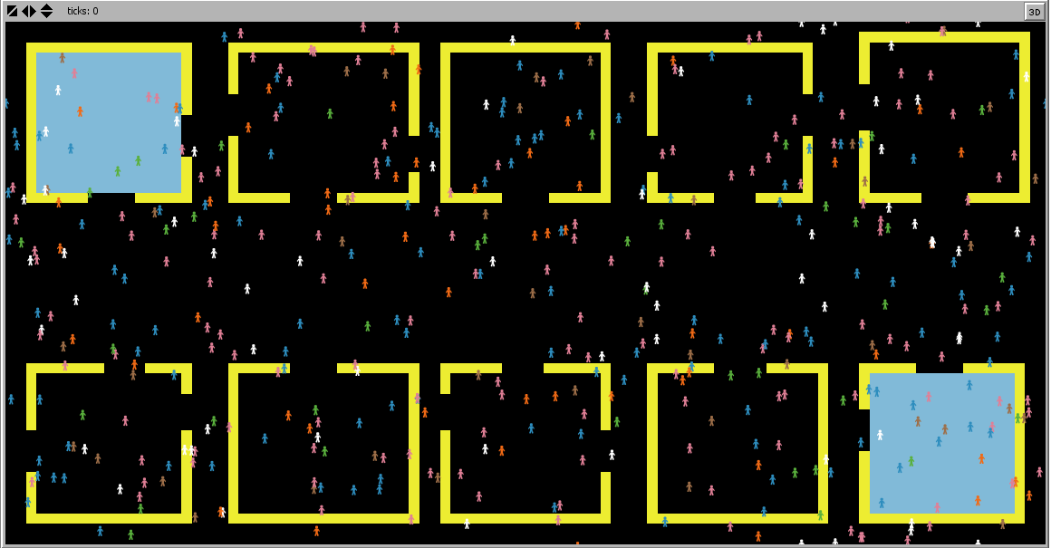
SETUP-MOCK-NU is a rough layout of Northwestern’s campus. It can be noted that the Greek houses are at opposite corners similar to how the fraternity and sorority quads are located on campus. It’s important to note that the Northwestern layout should be on a 100 max-pxcor by 50 max-pycor world space.

Parameters
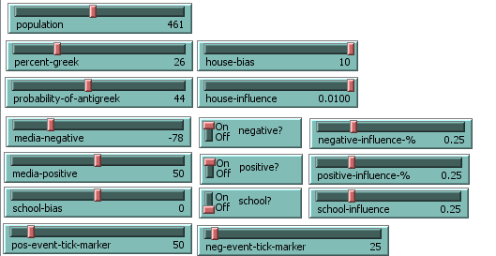
Population Slider that determines number of turtles on the screen. Percent Greek Percentage of turtles that will be Greek.
Probability-of-antigreek Probability that turtles that aren’t Greek will be anti-Greek.
house-bias Bias that Greek buildings will contribute to turtles’ bias while they’re in those buildings.
house-influence Percentage of house-bias that will affect turtles.
media-negative Negative bias that will contribute to turtles’ bias after a certain number of ticks pass as determined by NEG-EVENT-TICK-MARKER.
negative? Switch that determines whether negative events will be used.
negative-influence-% Percentage of MEDIA-NEGATIVE that will affect turtles.
neg-event-tick-marker Number of ticks that must pass before a negative event happens.
media-positive Positive bias that will contribute to turtles’ bias after a certain number of ticks pass as determined by POS-EVENT-TICK-MARKER.
positive? Switch that determines whether positive events will be used.
positive-influence-% Percentage of MEDIA-POSITIVE that will affect turtles.
pos-event-tick-marker Number of ticks that must pass before a positive event happens.
school-bias Bias that the school will contribute to turtles’ bias when an event (positive or negative) happens.
school? Switch that determines whether school bias will be used.

Plots and Monitors
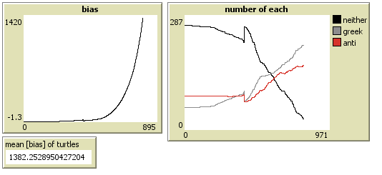

The average bias is plotted and monitored as the model runs. The number of Greek, anti-Greek, and turtles that aren’t either are also plotted as time passes by.
Analysis
Frequency of media coverage vs. Individuals The media has the capacity off covering a lot and generally has an inclination to seek out stories that are surrounding by controversy. With respect to Greek life, many of those stories involve illegal activities by fraternities or sororities. However, while media coverage can frequently barter the Greek system, does this necessarily mean that a college or university can expect its students to shift to be completely anti-Greek? Using NetLogo’s behavior space tool, I tested different conditions and observed their outcomes. The outcomes are focused on the number of Greek and anti-Greek turtles.
All of the following tests were carried out with the following variables staying constant at their set value:
- POPULATION: 400
- PERCENT-GREEK: 15
- PROBABILITY-OF-ANTI-GREEK: 25
- HOUSE-BIAS: 10
- HOUSE-INFLUENCE: .01
- MEDIA-NEGATIVE: -50
- MEDIA-POSITIVE: 50
- NEGATIVE-INFLUENCE-%: .25
- POSITIVE-INFLUENCE-%: .25
- SCHOOL-INFLUENCE-%: .25
- TICKS: 800 (equivalent of 2 years)
Test 1: Negative events occurring at twice the frequency of Positive Events

In this test, 10 runs were made with the frequency of negative events being at twice the frequency of positive media events. It can be noted in the chart that the numbers for anti-Greeks tended to be lower than that of Greeks throughout the ten runs. This suggests that media coverage alone will not be the deciding factor of how Greek life participation changes on a college campus let alone the opinion towards it. This idea is valid. After officially banning students from participating in Greek life at Amherst, there was a lot of outcry from students active in Greek life. It’s also common for Greek organizations to reestablish chapters at schools where they are banned from.
Test 2: Negative Media Only at different frequencies

In this test, 4 runs were made at different frequencies for negative events, starting at 20 ticks and ending at 400 ticks (after 1 full year). The results were rather interesting. The number of anti-Greek agents appear to follow the same pattern as the number of Greek agents, albeit not as large. Both tend to follow a decreasing trend which makes sense given that only negative media is affecting turtle biases. It’s interesting how resistive Greek turtles are to negative media. While anti-Greek turtles saw a spike in numbers early on at higher frequencies, Greek turtles didn’t witness a dramatic decrease early on. A more noticeable decrease is observed between a frequency of about 180 and 240.
Conclusion
From this model and tests, it can be concluded that media coverage alone, specifically negative media coverage, will not completely eliminate the presence of Greek turtles in the model. Even when negative media coverage was twice as more frequent than positive media coverage, it was not enough to eliminate Greek life. This, however, places an emphasis on the individual agents and their ability to maintain their bias high enough to not change into an anti-Greek agent and vice versa. This is reflective of the real world as there are still many students actively involved in their fraternities and sororities despite the negative media attention that their organizations might have received. Next steps could include an emphasis on the individual agents and what a student would use to assess similarity to another student (instead of just comparing year in school as this model does). This would of course be more complex but could offer a different outcome when combined with negative media coverage.

References http://www.sjsu.edu/getinvolved/frso/history/usfslhistory/
https://colleges.niche.com/rankings/best-greek-life/
http://www.usnews.com/education/best-colleges/the-short-list-college/articles/2013/12/31/10-universities-with-the-most-students-in-fraternities
http://www.huffingtonpost.com/2014/05/06/amherst-college-fraternities-ban_n_5275705.html
https://www.bostonglobe.com/metro/2014/05/23/amherst-college-students-decry-ban-underground-frats/SZg2XUTZrmBe46d8dDb85L/story.html
http://www.michigandaily.com/news/greek-week-raises-estimated-75000-charity
http://www.northwestern.edu/gogreek/

