Implementing

An agent-based model
change based on:

Expectations

of organizational

Leonardi, P. M. (2009). Why do
technologies and stymie
favor? Exploring misalignments
materiality. Human
35(3), 407–441.

people reject new organizational changes of which they are in
between social interactions and
Communication Research,

Eleanor Anderson, EECS 472
Real Case

- A car company introduced new software for its crash analysts

- The software had features that many analysts wanted

- And yet, some concluded it was useless and discarded it

Why?

- Some analysts came to believe the software was intended for something other than what the developers intended.

- When it didn’t serve that function well, they discarded it

- Others didn’t know what the software was intended for and explored it’s features openly
Research Questions

- Can the patterns of expectation and usage Leonardi described be replicated in an agent based model?

- What might happen in other scenarios?
Agent Based Model

Each person can hold up to two expectations about a technology’s affordances

Expectations can be about feature a or b, and can be positive or negative

If a person bumps into someone else holding an expectation about a feature she didn’t know about, she takes that on

If a person encounters the technology she tests her positive expectations, to see if the technology really can do what she thinks

If a person encounters the technology but has no expectation she learns from the technology

Replicating the Case
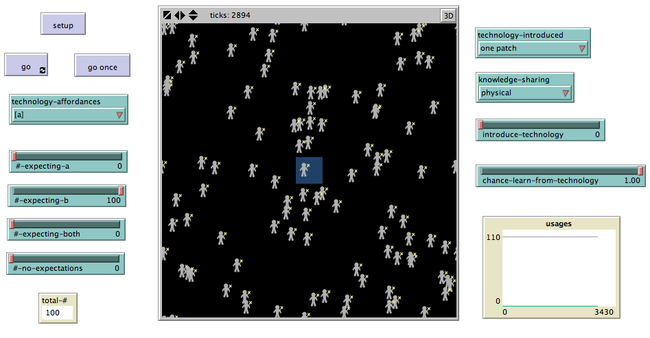

Technology affords A; People expect B: No usage

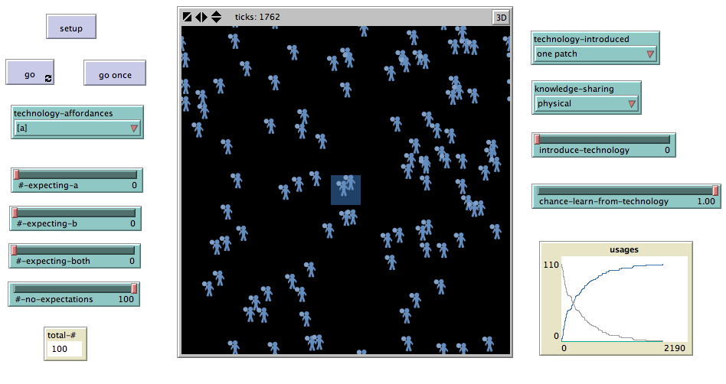

Technology affords A; People have no expectations: Full usage
Other Scenarios

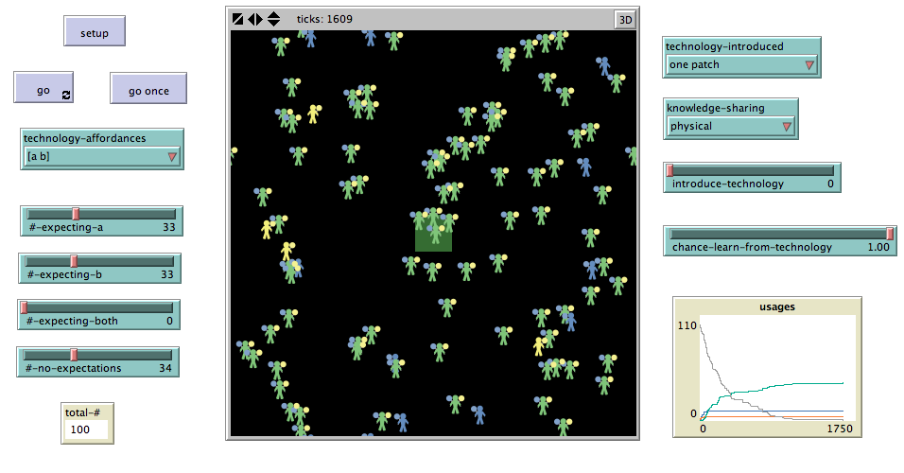

Technology affords A and B; People have mixed expectation: Mixed Usage

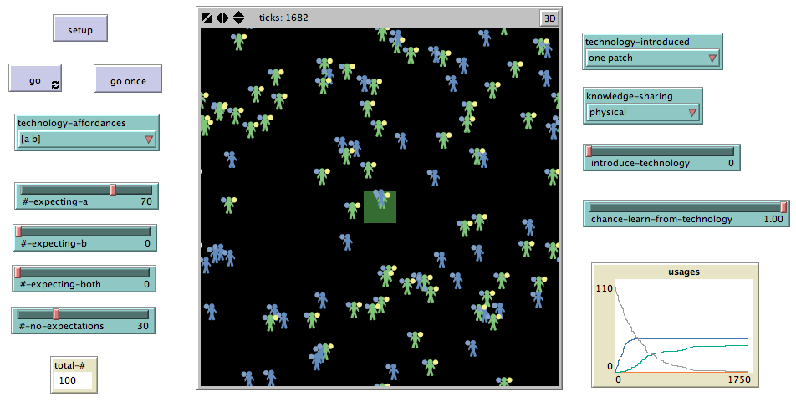

Technology affords A and B; Most people expect A: Need ~30% of people not to hold clear expectations to get mixed usage
Next Steps . . .

This is a work in progress!

People exist in networks: what happens if information and technology travel only through network ties?

I’m also working on an additional model of organizational change examining what happens when individuals advocate for and against change.

