
Virtual Aquaponics
An Educational Netlogo Agent-Based Model of Aquaponics System
Asmaa Aljuhani
6/10/2013
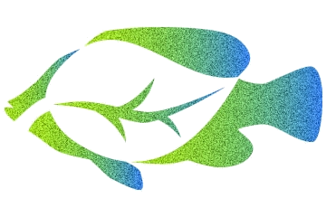

EECS 472 – Designing and Constructing Models with
Multi-Agent Languages
Prof.Uri Wilensky

Abstract
Imagine how it is so excited that you can produce your own organic vegetable simply in your backyard. Aquaponics is the integration of aquaculture and hydroponics. Aquaponics is known to be the most efficient of all food production systems. Three important elements in any Aquaponics system are plants, fish and beneficial bacteria. Simply, feed the fish, the bacteria turn the fish wastes into plant food and the plants clean the water for the fish. The purpose of this paper is to introduce one of the most efficient food production systems the Aquaponics system, explain how it works and give detailed system design and implementation.

Introduction
Imagine how it is so excited that you can produce your own organic vegetable simply in your backyard. Aquaponics is the integration of aquaculture and hydroponics. Aquaponics is known to be the most efficient of all food production systems. Aquaponics is one of the agricultural systems that lead into a sustainable food production. The term Aquaponics can be divided into two parts "aqua" which refers to water and "ponics" which refers to labor or toil. In another word, Aquaponics is a system that circulates the water between two mediums in which the waste produced by farmed fish or other aquatic animals supplies nutrients for plants grown hydroponically, which in turn purify the water. The following sections describe how Aquaponics works, the design, the methods that have been used and the result of the system implementation and processing.

How Aquaponics works?
This section explains how the Aquaponics system works. Aquaponics consist of two main parts : Aquaculture (fish farming) and Hydroponics (soil-less growing of plants). It combines fish and plants in a "closed" integrated system. Closed means that there is no water loss - so Aquaponics is a very water efficient way of growing plants and fish, requiring only one tenth the water!
Fish wastes in the water are converted by beneficial bacteria to nutrients (plant food). Plants then use the nutrients to grow and clean water is then returned to the fish tank. The fish, plants and bacteria create a mutually beneficial relationship where the only input needed is to feed the fish and top up the water.
In order to create a balance in the aquaponic system, fish and plants need to be balanced. If there are too many fish, then the plants will not be able to extract enough of the nutrients and clean the water, if there are too many plants, then there will not be enough nutrients in the water for all of the plants.
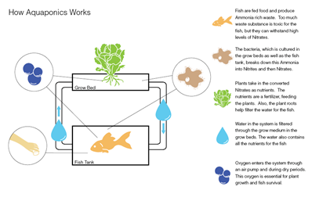

Design:
In this section, reader will get to know NetLogo, a programmable modeling environment, in which the models are built by. Then, I’ll provide an overview of the two Aquaponics simulation models. the first model is a high level of the ecosystem and the other one focuses on the water part. Finally, I provide detailed implementation for these models.

NetLogo
NetLogo is an agent-based programming language which was authored by Uri Wilensky in 1999 and has been in continuous development ever since at the Center for Connected Learning and Computer-Based Modeling. It teaches programming concepts using agents in the form of turtles, patches, and the observer. NetLogo was designed for multiple audiences in mind, in particular: teaching children in the education community, and for domain experts without a programming background to model related phenomena.

model overview
Using Netlogo, I designed and implemented two agent-based models that simulate Aquaponics system. The first model called Aquaponics-edu model which shows the big picture of how aquaponics system works. The second one, Aquaponics-details model, shows in details how fish waste turn into something that is beneficial for plants. Following is details about each model.

Aquaponics-edu
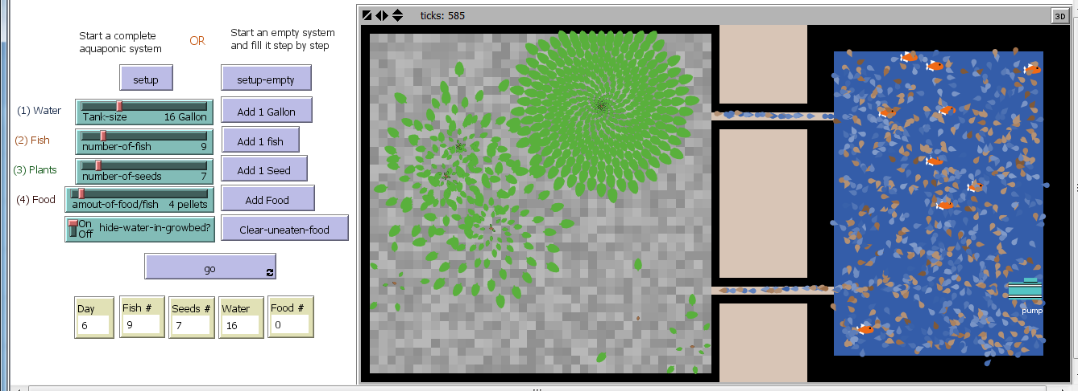
This model can be used to educate people about the aquaponics system. It illustrate the main components of the system ( fish , plants ) ,the relationship between them, and how the whole system behave.
Here is a description of how the model is visualized. When a user first view the model, s/he will see two parts: a blue fish tank on the right and a gray growbed on the left and they are connected with two tunnels which allow water to circulate in the system. for educational purpose, the model can either start filled with the components or empty and the user fill it step by step. Fish tank holds water and fish. as well as fish food which is added once each day. In the fish tanks there is pump which pumps water through a tunnel to the growbed where the plants’ seeds are. water can return back to the fish tank through the other tunnel.
The model works as following: when fish eat food they produce waste in the water, the water is pumped to the growbed, seeds in the growbed filter water from waste and grow, lastly, the water return back to the fish tank.
Users can modify variables for the system. They can choose how many fish they want in the tank, how many food (pellets) per fish, how many seeds in the grow bed and the amount of water. User can choose different combinations of variables and see how the system will act upon these variables.
Users can also start empty system and fill it with components. They can add water and fish and food and see how the system will work without plants. They can also add more food and see if this will benefit the system or harm it. In the experiment section, a description of how participants interact with the system will be provided.

Aquaponics-details
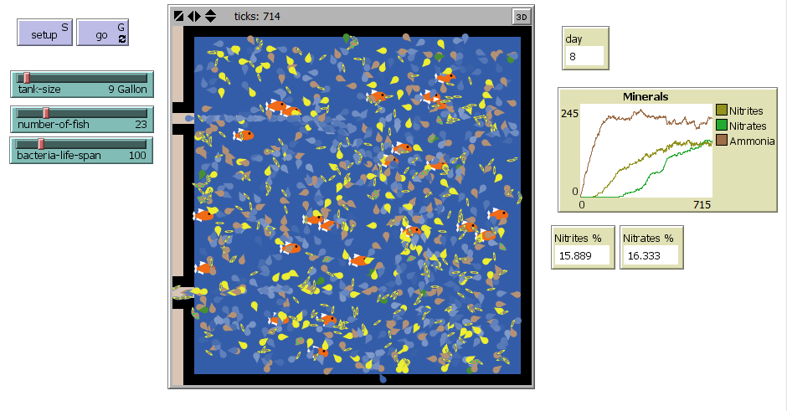
This model focus on how nutrient-rich water that result from raising fish provides a source of natural fertilizer for the growing plants. This conversion is done by 2 types of bacteria: Nitrosomonas ( turns ammonia into Nitrites) , and Nitrobacter (turns Nitrites into Nitrates). This conversions create a sustainable ecosystem where both the fish and plants can thrive.
The interface for this model shows the fish tank with number of fish that can be specified by the user. when fish produce ammonia, The first type of bacteria (Nitrosomonas) grow and convert the ammonia to Nitrites which is intermediate compound. This Nitrites is then converted to Nitrates (NO₃⁻ ) by the second type of the bacteria (Nitrobacter). It is beneficial for plants to consume because it serves as an essential plant nutrient helping with tissue development and building immune systems, and it helps plants develop and produce seeds. In the system, water is the carrier for all these compounds that circulate the system from the tank to growbed, then it is filtered by the plants and return clean to the tank.

Implementation
Now that we understand the concepts behind the Aquaponics and how complex it is, it is useful to simulate this system using Agent-based model programming that allow users to modify different factors and see the consequences of their changes. In this section we will demonstrate the implementation of the two models and discuss the assumptions we made in order to design these models.

Agents:
Agents are individual or collective entities that is used to represent a component. Agents can be turtles, patches or links. These are the agents that is used in the two models:
- Fish (turtles) which represent the aquaculture in this system.
- Plants (turtles) which represent the hydroponics in this system.
- Water (turtles) which is the media that circulate the system.
- Food (turtles) which represent pellets for fish.
- Nitrosomonas bacteria (turtles) that convert ammonia to Nitrites.
- Nitrobacter bacteria (turtles) that convert Nitrites to Nitrates.

Properties for agents:
Fish has tank size which store the amount of eaten food, based on that variable fish produce ammonia. Both bacteria have life span that determine how long they can live. Water has clean property which holds the amount of Ammonia produced by fish it range from 1 to 5. if fish is surrounded by water that is not clean ( clean = 4) they die. Water also has boolean variables (Nitrites? , Nitrates?) that shows whether a water turtle has one of these compound.

Agent Behavior:
Fish :
I swim in the tank
I eat food
I waste
Plants:
If I encounter water
I grow
I filter water
Nitrosamines:
If there is Ammonia
I grow
I convert Ammonia to Nitrites
Nitrobacteria:
If there is Nitrites
I grow
I convert Nitrites to Nitrates
Water :
I move within the tank and growbed
I carry fish waste
If I reach the pump
I cross the tunnel to growbed
If growbed reach its max-capacity of water
I cross the tunnel back to the tank
Food:
Each day (100 tick):
I am added
If I am not eaten by fish
I turn to toxics

Methods:
In order to test the effectiveness of this model in the field of education, I interviewed 9 people. In this section, a detail about participants is provided, as well as the method for this experiment , and finally the findings.

participants:
I interviewed 9 people. 66% (6) of them were at elementary school (10 - 12 years-old). and 33% (3) were adults. About their gender: 66% female and 33% male. 22% of participants have fish at home and most of the participants have plants.

Education materials :
For the purpose of this experiment, I created a slides that demonstrate the Aquaponics idea and concepts )ٍSlides are provided in the appendix of this paper). the presentation also contain a video clip that gives a visual instruction of how aquaponics works. work sheet also is provided for discussion.

Experiment:
For my experiment with the kids I have interviewed; firstly, I have showed the participants the slides and the video; after that I asked them questions about what they watched and I asked to write their answers. secondly, I show them my real model and let them play with it. after that I have asked them the same questions and observe any changes on their answers.

Result:
Findings were pretty interesting. When I first showed the slides and let participants try to solve the worksheet. they were trying to solve the questions based on their imagination rather than scientific reasoning. they were unconvinced by their own answers. Participants who had fish were much better in this part than who don’t. From participants answers, I was able to figure out that they got the big picture of the system and it only trigger their emotions. One participant describe the system as “cool!”. The second part of the experiment was to show the model. Participants were easily able to figure out how it works. The part where participant can build the system by adding a component a time works the best for this purpose , specially elementary schools ages. They were able to see clearly the role of each component. for example, one participant tried to add water and fish only. Without plants, water remains unclean as they (water turtles) weren’t filtered.The Aquaponics-details model was advanced for elementary school age. however, it gave clear explanation for adult participants. For the worksheet, participant were sure of their answers and gave a scientific reasoning. Most of participant asked for further information as they were excited to build their own aquaponics.

Conclusion
Aquaponics is known to be the most efficient food production systems. Aquaponics is the integration of aquaculture and hydroponics. Agent-based programming is the best way to design such system as it (Aquaponics) has a lot of factors and components that can be modified until reaching the balance stage between the components.

References:
Diver, S. (2006). Aquaponics—Integration of Hydroponics with Aquaculture.National Sustainable Agriculture Information Service, 1-27.
Nelson+pade , Retrived June 1, 2013. From : http://aquaponics.com/
NetLogo itself: Wilensky, U. 1999. NetLogo. http://ccl.northwestern.edu/netlogo/. Center for Connected Learning and Computer-Based Modeling, Northwestern University. Evanston, IL.

Appendix:

Presentation

Worksheet

