Asmaa Aljuhani
Professor Wilensky
EECS 372
May 27, 2013
Aquaponics system
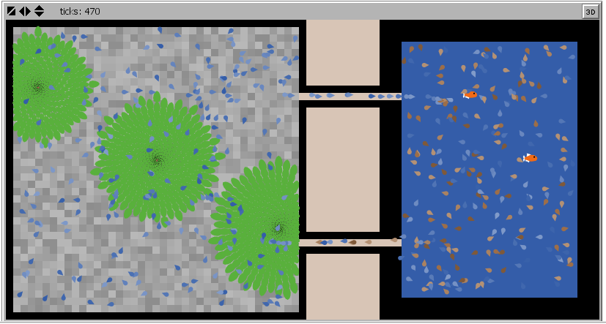

Agent behavior:
Water: in this version, water flow between the tank and the growbed through the tunnels. Water turtles have a clean variable which holds a range from 1 to 5 that reflect the amount of ammonia in the water.
Fish: in this version, fish produce ammonia in water.
Plants: plants have the ability to grow when they absorb water. They also filter water from ammonia and make it clean for the fish.

System behavior: fish produce ammonia in water. When water circulates into the system, Plants grow and filter these ammonia which make the water clean.

Model output: The current model provides a good vision of the entire environment as well as the basic behavior for the agents.

Questions: What plots and monitors the model needs to make it more interesting?

Next steps: implementing food turtles and its relation behavior for fish.
For 472 requirements: I am going to build another model that focus on the fish tank. This model will explore in details how ammonia turns into Nitrates by bacteria.

