Lizz Bartos
EECS 372
Designing and Constructing Models with Multi-Agent Languages
Prof. Uri Wilensky
15 July 2013
Safe Sex Attitudes and Behaviors
Overview
This NetLogo model aims to simulate the spread and development of safe sex attitudes and behaviors in response to the presence of a sexually transmitted infection (STI) throughout a social network of young adults. It also takes into account how these variables interact with one another and change over time using theories of attitude change and certainty.

Relevance and Motivation
This project specifically focuses on modeling college students in the United States, a specific demographic which contain young adults who may have multiple sex partners and who would engage in sexual activity frequently enough that this lifestyle would be impacted by STIs. Male and female students come to universities with diverse backgrounds, including different educational levels and attitudes towards practicing safe sex. It was of interest to see if a NetLogo model could emulate those behaviors. The model also aimed at modeling the complex social behavior associated with sexual partnering.
This model focuses more on the impact of sexual attitudes and behaviors of agents in relation to the spread of STIs, rather than the biological mechanism of the spread of sexually transmitted infections themselves. This contrasts with previous models in the NetLogo library that focus on the actual spread of a disease, such as the AIDS model, the Virus model, or the Virus on a Network model.

Guiding Questions
- What factors seem to be most influential in determining whether an individual will practice unsafe sex and thus potentially contract an STI?
- What factors influence the spread of attitudes towards safe sex?
- Are the two above questions interdependent? What implications could this have for targeting information campaigns to this age group?

Literature Background - Rationale for Agent Rules
In order to make the model a closer simulation to reality, scientific literature was evaluated to determine both the factors that influence the practice of safe sex and the expected responses to the factors by the agents. Reasonable assumptions (constants) required for the model’s functionality were also based on the latest available research.
Networks Rationale
Researchers have repeatedly identified that social networks are crucial in examining the spread of different types of infections, as well as attitudes – many of these studies specifically focused on STIs or diseases like HIV/AIDS during the early 90s. Consequently, the NetLogo programming was set up as a set of interconnected simple networks.

Attitude Development
Specific research articles geared towards the development of attitudes or knowledge regarding safe sex and condom usage was limited, so I used existing literature relating to attitude development in general. Most of my assumptions were derived from the work of Tormala and Rucker (2007), who provided a meta-analysis of existing literature about attitude certainty over the past decade, and proposed a multifactor model of attitude certainty.
In trying to address the question “How do people’s perceptions of their own responses to persuasive messages affect attitude certainty?”, the authors take an approach that "focused on the metacognitive factors that shape attitude certainty" (p. 475). Through their research, which "focused primarily on the way attitude certainty is influenced by people’s encounters with persuasive messages" they "suggest that people "form attribution-like inferences about their attitudes" (p. 475) and “can become either more or less certain of their attitudes following an encounter with a persuasive message, depending on their perceptions of their response to that message and the situation in which it occurs." (p. 476). By "focus[ing] on two forms of attitude certainty: attitude clarity and attitude correctness", the authors "…have proposed a multifactor model of attitude certainty, suggesting that the general state of attitude certainty … might reflect a number of different certainty- type assessments." (p. 482). Tormala and Rucker’s thoughts are summarized in the following graphic.
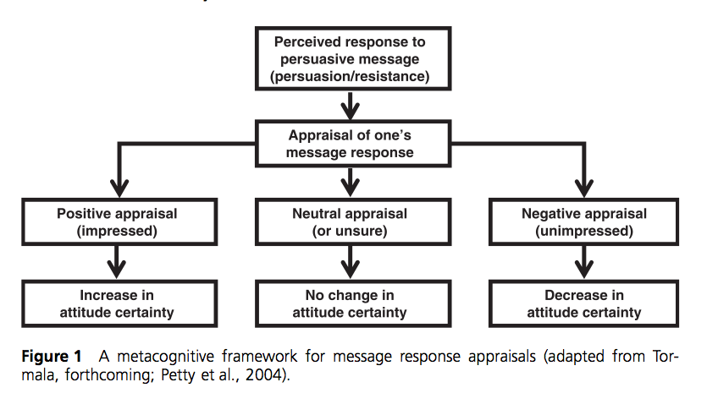
This work suggested to me that the NetLogo model should have two variables, Certainty (attitude clarity in Tormala and Rucker’s designation) and Justification (attitude correctness in Tormala and Rucker’s designation), which could influence Attitude (attitude certainty in Tormala’s and Rucker’s designation). Attitude, in turn, would influence the likelihood of whether a couple practiced safe sex during a sexual encounter.
Additionally, Petrocelli et al. (2007) determined that "… [attitude] clarity and [attitude] correctness could be measured separately, and each appeared to explain unique variance in global feelings of attitude certainty." (p. 482). This supported the choice made in my NetLogo program that the Certainty and Justification variables would be independent.
Attitude certainty has also been of interest in the research literature in part because one of the most notable consequences of attitude certainty is attitude-behavior correspondence. Petrocelli et al. note "it is well established that high certainty attitudes are more predictive of behavior than low certainty attitudes." (p. 487) and "as attitude certainty increases, attitudes become increasingly likely to guide behavior." (p. 473). This observation provides the additional justification in my NetLogo programming that behavior (likelihood of practicing safe sex) can be functionally dependent directly on the Attitude variable.
Tormala and Rucker (2007) summarized through their review of literature, "people tend to be more certain of their attitudes when those attitudes are formed through direct (e.g., first hand interactions) rather than indirect (e.g., second hand viewing or reading) experience.” (pp. 470-471). This supports another assumption made in my NetLogo model, which is that contracting an STI significantly increases one’s attitude that they need to practice safe sex.
The impact of Justification (increased knowledge) "has been shown to foster greater attitude certainty (e.g., Smith, Fabrigar, MacDougal, & Wiesenthal, forthcoming)." (p. 471). Smith et al. (forthcoming) recently demonstrated that " the more consistent one’s underlying [attitude-relevant] knowledge, the more certain one is of one’s attitude." (p. 472). This provides additional support for the use of the Justification variable as influencing Attitude in my NetLogo model.
Other aspects in development of the functional attributes of the Attitude variable in my NetLogo model can also be gleaned from the literature. As indicated in Tormala and Rucker’s (2007) review of attitude certainty, repeating one’s attitude to others has been shown to increase attitude certainty (p. 471). Additionally, Petrocelli et al. reasoned that “repeated expression might increase feelings of attitude clarity but not correctness as repeatedly expressing the same attitude should facilitate the subjective sense that one knows what one’s attitude on a topic is without making that attitude seem any more correct or valid." (p. 483). This work thus suggested that the Certainty variable should be reinforced every time the attitude was repeated, and this feature was also incorporated into my NetLogo model.
A further observation from the literature suggests that the more certain one is, the less likely one is to change one’s attitude. Petrocelli, et al. concluded "…attitudes held with high certainty are more likely than attitudes held with low certainty to resist persuasive attacks or other influence attempts." (p. 473). Other researchers noted that "attitudes held with greater certainty are more persistent over time than attitudes held with less certainty (Bassili, 1996; see also Bizer et al., 2006)." These observations thus provided another functionality that had to be included into the NetLogo model. When Certainty is high, the ability of attitude to change must be low.
The literature also supports that similar attitudes can engender a reinforcement of one’s own attitude. Tormala and Rucker (2007) concluded based on their research that people tend to be more certain of their attitudes when they believe other people hold similar attitudes. This may be because "attitude consensus, or perceived social support for one’s attitude," [also referred to as "social consensus" (p. 472) or "response similarity" (p. 480)] "is thought to signal that all the evidence points to the same attitude, which boosts attitude certainty if one holds that attitude oneself." (pp. 472-473) …"In essence, people infer validity from social consensus" (p. 472). This facet of Attitude was also captured in my NetLogo model. In an interactive exchange between two agents, the magnitude of the Attitude variable was thus compared. If both agents interacting had either a high Attitude score (both in agreement that safe sex should be practiced) or a low Attitude score (both in agreement that safe sex should not be practiced), the resulting Attitude was adjusted upward or downward to provide reinforcement of the Attitude.
Finally, Tormala and Rucker (2007) also note that "participants’ attitudes were more resistant to this attack when they were high rather than low in clarity" (p. 484). This suggests that my NetLogo variable functionality needed to include the appropriate mathematical expression such that when Certainty tended to be the weakest in strength (a value of 50 on a 0 to 100 scale) that the ability to change Attitude would be highest.
A chart depicting the influences on the variables used in my NetLogo program are indicated below:
 | Initial factors | Cause to Increase | Cause to Decrease
Attitude (towards condom use) | Condom use desire | Potentially talking to peers with attitudes above 50  Have sex with a partner that is infected and use protection  Super boosted if contract an STI and know it | Potentially talking to peers with attitudes below 50
Certainty (about your attitude) | Mesosystem influence | Every time you repeat your attitude to someone else  If you feel like others have similar attitude as you | Whenever your attitude is challenged by significantly different attitude
Justification (about your attitude) | Sex education including condoms | Super boosted if contract an STI and know it | “Getting away with” unsafe sex

Model Parameters

Social network: Parameters are provided to initialize a simple social network, consisting primarily of discrete social groups (cliques). Users can control the number and size (number of members) of cliques (num-cliques and clique-size sliders), and whether they are initialized with a limited number of inter-group links between “clique leaders” (social-butterflies? switch enabled). These cliques consist of agents that primarily interact with members of the same group. Each agent has a specified number of desired friends (avg-num-friends slider), which generates a fixed number of friend links within the group. Specific values for each agent start with random value drawn from a normal distribution centered around a specified mean value.

STI characteristics: Users can control the likelihood (out of 100%) of an infection spreading during an unprotected sexual encounter (infection-chance slider), and choose which genders (if any) show symptoms of the infection (using the symptomatic? chooser). When the user presses setup, one random agent in the model will be infected by default. However, the user can also choose to select an agent in the model to infect with their mouse, or press infect-random to infect an additional agent in the model with a sexually transmitted infection. These functions are optional, but can be called multiple times before, or at any time during, the simulation.

Agent Parameters Impacting Practice of Safe Sex

Attitude: consistent first sentence. Users can separately define the average initial intention of a male vs. female agent in the model to practice safe sex, i.e., condom use (using the avg-male-condom-intention and avg-female-condom-intention sliders, both with ranges from 0 to 100%). A randomly generated value for each agent based on a normal distribution is set based on the initial mean.

Certainty: Agents have an initial confidence in their attitude towards practicing safe sex, which influences how resistant they will be to adopting alternate viewpoints. The initial average population certainty value is set with the avg-mesosystem-condom-encouragement slider [range 0-100%]. This variable reflects how much of their upbringing encouraged safe sex. These views might consist of parents’ beliefs, life experiences, religious attitudes, etc. Certainty can influence the likelihood of practicing safe sex, but is independent of attitude. Willingness to change one’s attitude would be proportional to a corresponding variable equal to [100 - attitude].

Justification: Justification is the initial reasoning why agents have their attitude and what logical explanations they have to rationalize their attitude. Users can indicate the percentage of agents that receive sexual education including condom use, (%-receive-condom-sex-ed [slider 0-100]). Agents that receive health education including information about condoms as protection against STIs will have a higher level of accurate knowledge about safe sex practices and benefits, and those who don’t will have a lower level of accurate knowledge. Both values will be normally distributed over the higher or lower value and used as the initial Justification for a given agent.

The variable of Attitude influences an agent’s Likelihood of engaging in safe sex using protection. The variables of Certainty and Justification will affect each agent’s Attitude. Likelihood will ultimately determine whether the agent indeed practices safe sex.

The approximate likelihood of an agent practicing in safe sex is demonstrated through the color of each agent. Enabling the show-labels? switch will display the exact likelihood value of each agent to engage in safe sex behaviors. The user can press go-once to see changes per step (often very useful if examining a person that was just infected) or press go to view a continuous progression of the model simulation.

Agent Parameters
Individual agents are initialized by setting gender and unique member variables. Custom values for each agent are generated randomly following a normal distribution using the average global variables indicated above, as well as some additional variables that are hard-coded and invisible to the user. The actual functional dependence of the three components of Attitude, Justification and Certainty on the Likelihood of practicing safe sex will be discussed in further detail below.

Attitude: An agent’s attitude is initially set to a random selection from a normally distributed range centered around a user specified mean. Attitude evolves over the course of the model and is updated on each tick based on talking to peers or getting infected.

Certainty: Certainty is initially set to a randomly generated value using the variable avg-mesosystem-condom-encouragement. Although Certainty in some studies is an indicator of actual behavior, in this NetLogo model Certainty as an influencing variable for Attitude, which ultimately determines the likelihood of whether safe sex is practiced.

Justification: Justification (knowledge) is initially set to the level of accurate education this agent has about safe sex and condom usage.

Agent Appearance

Shape: Agent shape is determined by gender and health status. Infected agents have a dot on their shape, and the color of the dot indicates whether or not they “know” they are infected (white: known? = true; black: known? = false), which is based on being symptomatic (i.e., exhibiting symptoms). Male and female agents take on the shapes similar to those used in American restroom signs.

Color: The color of the agent indicates his or her individual likelihood of practicing safe sex. A green agent is more likely to engage in safe sex, while a red agent is less likely to use a condom. The likelihood is a scale from 0 to 100, and agents that are 50% likely of having safe sex are displayed as white.

Label: The labels, if enabled, also indicate each agent’s likelihood of practicing safe sex as an exact value from 0 to 100 and is more accurate because color is set to only a total of 20 different hues over the same range.

Links: In this model, agents can have multiple friends, but only one sexual partner at a time. The type of relationship between the two agents is distinguished by color of the connecting

Model/System Behavior

Model Setup
The social network of agents is arranged as mostly discrete social circles, with some (optional) central agents (“social butterflies”) that have links to central members of other social groups in addition to links to all members in their clique. Agents start with a certain number of friendship links (limited to between others in their clique), and no sexual partner links. Friend links are gender independent, but sexual partners are not – they require a coupling of one male and one female agent. Individual agent variables are assigned randomly following a normal distribution based on slider or global values.
The model initiates/initializes by having/making one male and one female agent contract a sexually transmitted infection (an STI). The model continues to run until a stop condition is met.

Agent Behavior
On each tick:
- Agents interact with their peers about Attitudes towards safe sex.
  - Agents talk to their friends and sexual partner (if any), and update their Attitude about practicing safe sex (and consequently likelihood to practice safe sex).
    - Consequently, this might impact their personal likelihood of practicing safe sex.
  - The number of friends the agents talk to is based on their Certainty at a given tick
  - Agents compare their own Attitude and their friend’s Attitude, which will influence the magnitude and sign of the change of Attitude at each tick
  - Agents check their Certainty and their friend’s Justification, which will also influence the magnitude and sign of the change of Attitude at each tick
  - The change in Attitude is used to update each agent’s Attitude to its new state
  - Certainty and Justification are updated
- Agents look for a sexual partner (male-female coupling).
  - If an agent is NOT coupled, s/he might try to find another single agent of the opposite gender to form a sexual partnership with. Any agent can initiate coupling if they are not coupled and random chance permits (based on their personal/individual coupling tendency).
  - A hierarchy of coupling preference exists: The probability of successfully coupling decreases for each of these types of potential partners:
      - First agents look at existing friends of the opposite sex;
      - If they have none, then they choose a person of the opposite sex within their friend group;
      - If there isn’t one, then they resort to choosing the closest non-linked opposite sex agent.
      - If both partners are willing to become a couple, they form a sexual-partner link (if the two agents were previously friends, this destroys their friendship link).
      - If they are already coupled with a sexual partner, the two agents just increase length of their relationship (agents are monogamous in this simulation).
- Agents make friends.
  - Any agent can initiate “friending” with any other agent (independent of gender) if they (and the potential friend) have not reached their maximum limit of friends and random chance permits (based on their personal/individual friendship tendency).
  - A hierarchy of friending is assumed. The probability of successfully becoming friends decreases for each of these types of potential friends:
    - First agents try to choose an agent within their friend group that they are not currently linked to;
    - If there isn’t one, then they resort to choosing the closest non-linked agent.
    - If both agents are willing to become friends, they form a friendship link.
- Agents that (currently) have a sexual partner can potentially uncouple. Agents will uncouple if the length of the relationship reaches the commitment threshold for one of the partners.
  - The order in which these functions are called on each tick (uncouple after making friends and couple) helps restrict who can couple after uncoupling, simulating that exes would not be immediately friending each other again; this model does not (intend to) simulate instant rebounds
- If agents are coupled (have a sexual partner), they have sex.
  - The likelihood that the couple will engage in safe sex (choose to use a condom) depends on a function of the likelihood of both participants.
  - If one of the partners is infected and the couple has unprotected sex, there is a chance that they will spread the disease to them/the other partner will become infected (based on the infectiousness/infectivity of the disease). An infected agent is distinguished by a dot on their shape.
- Agents check if they are infected. Only agents of genders that are symptomatic will know they are infected.
  - If an agent knows s/he is infected, s/he will always want to practice safe sex for the rest of the simulation.
  - If an agent has unsafe sex and does not notice any consequences (either is not infected, or is not symptomatic, regardless of infection status), that agent’s likelihood of practicing/inclination to practice safe sex will decrease.
- Agents do not move (i.e., network is fixed) to allow the viewer to observe the spread of disease easier (a concession to unrealism to improve program clarity).
Model Output
While the model is running, users can observe how attitudes and infections spread through friend and sexual partner links. Note that this can be rather dramatic in the beginning, but eventually attitudes stop changing as rapidly, and the simulation usually comes to an end based on stop conditions described below. Display of colors of the agents can help users see a general pattern, while displaying the labels gives more exact values.
A histogram displays the likelihood of male vs. female agents to practice safe sex, as well as plotting the components (attitude, certainty, and justification), that influence likelihood of safe sex for every agent. Users can also observe percent of the population infected (separated by gender as well) on a chart.
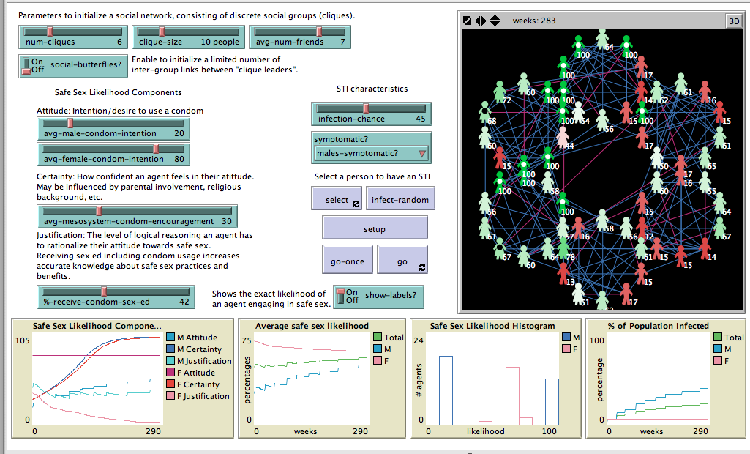

Stop conditions
The system has the following stop conditions:
- If every single agent in the model is infected
- If the certainty of every agent gets so high that attitudes will not change anymore (based on this model’s implementation)
- If every agent comes to the same attitude consensus
- If the likelihoods of the agents stop changing by a preset criteria

Assumptions and Simplifications
This model only simulates heterosexual/heteronormative (cisgendered), college-aged young adults - both male and female. Agents in the simulation can only have a maximum of one partner at a time (serial monogamy). The complexities of different types of sexual behaviors (abstinence, long-term monogamy, or strictly hook-ups) are not included in the model.
Although STIs may be transmitted through avenues other than sexual behavior, as in drug needles, childbirth, or breastfeeding, this model focuses on the sexual interactions, as they are most common form of transmission - especially in the age demographic in question. Additionally, although there are forms of protection against STIs/STDs other than condoms, it is the form of sexual protection that is most prevalent and accessible for the demographic of interest.
Although some members of the cliques have or develop links to agents in other groups, the social groups are generated at the beginning of the simulation and remain fairly static. Agents cannot change group affiliation over time, and are not able to be part of more than one social group at a time.
Simplifying Assumptions:
- There is only one type of sexually transmitted infection (STI)
- Condoms are the only form of STI protection
  - Condoms were chosen for this simulation as they are the most accessible and reliable form of protection among the target demographic of interest for this model.
- Agents are serially monogamous – they can only have one sexual partner at a time
- Agents will only know that they have contracted an STI if they are symptomatic
  - There is no simulation of testing for STIs. Agents also don’t randomly get tested, nor is likelihood of getting tested based on gender
- Agents are not malicious; If an agent is symptomatic, s/he will know they have an STI, and will want to always practice safe sex from there forward.
- Since agents that know they have contracted an STI will practice safe sex from that point forward, no allocation is made for STI testing, treatment, or recovery.
- Condoms are assumed to be used perfectly and entirely effective against the spread of STIs.

Behavior Space Analysis
Although this generalized model could be used in many ways, the treatment I will discuss below will focus specifically on how the likelihood of practicing safe sex could be increased, especially in the context of going back to part of one of my guiding questions: “What implications could this have for targeting information campaigns to this age group?” I wanted to explore if initial certainty (in this model, assumed to be encouragement from parents and home life about safe sex) or initial justification (in this model, modeled by percent of agents that receive sex education including condom use information as protection against STIs) would have a greater impact on the spread of attitudes, infection rates, and likelihood of agents practicing safe sex.
The NetLogo model was run over the entire space of the two variables in question. The choices of only males being symptomatic, and the infectivity level being set to 45%, were based on the characteristics of gonorrhea, an extremely common infectious disease that is prevalent in the age demographic of interest (CDC, 2013). Each combination of parameters was run five times and averages developed for the function in question at the end of the run for each parameter combination. Scatter plots were then generated to allow conclusions to be drawn for the initial estimates.
The first set of plots indicates the average safe sex likelihood as a function of either initial justification (%-receive-condom-sex-ed) or initial certainty (avg-mesosystem-condom-encouragement). It can be seen from the plots that in general the initial variables are only mildly correlated with the average final end state. There is a slight rise in safe sex likelihood with initial justification.
When broken down by males and females, one can observe a difference for safe sex likelihood. Female safe sex likelihood does show a modest increase with initial justification, while Male safe sex likelihood is flatter. Perhaps of more note is the absolute level of safe sex likelihood. Females demonstrate a safe sex likelihood that ranges from 60 to 75%, while males demonstrate a range of only 30 to 50%.
When safe sex likelihood is compared between males and females based on initial certainty, one sees surprising differences. Male safe sex likelihood moderately decreases with increasing initial certainty, while female safe sex likelihood modestly increases with increasing initial certainty. This result for males is a bit puzzling. Additional work would be required to perhaps determine if there is an interaction between the other initial variables.

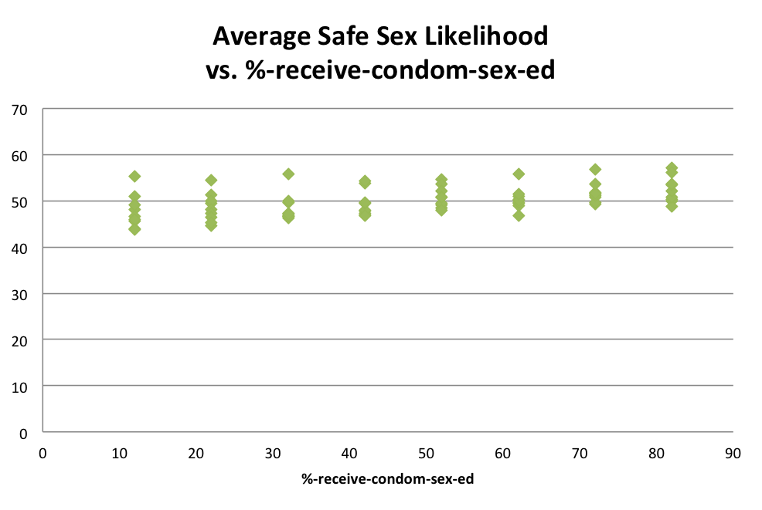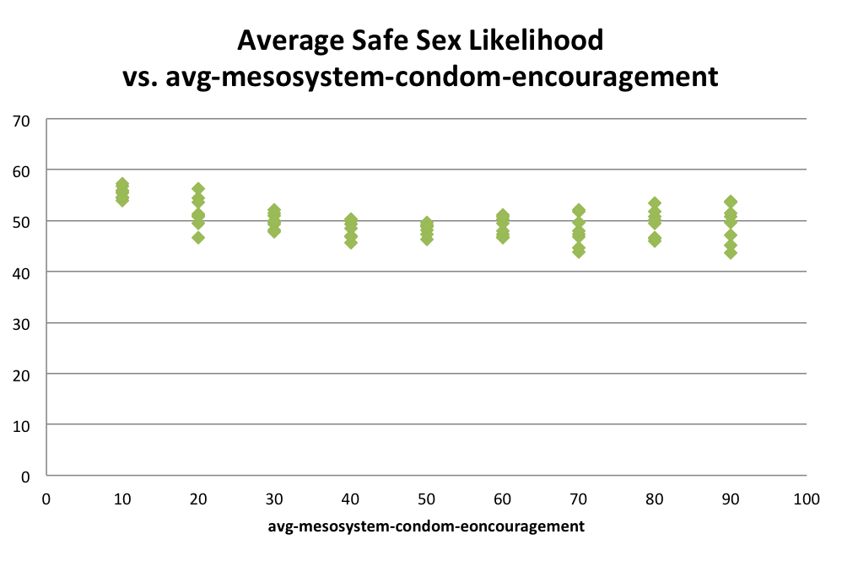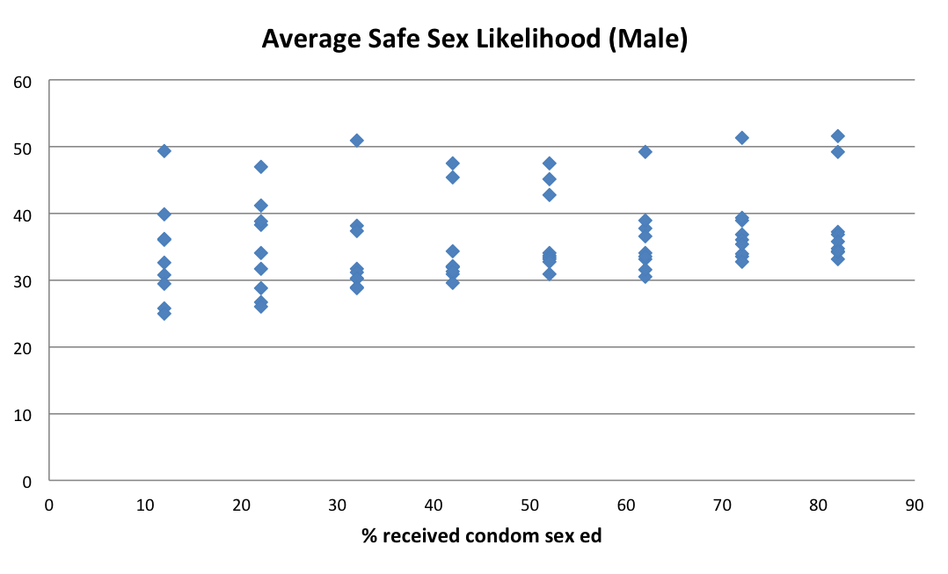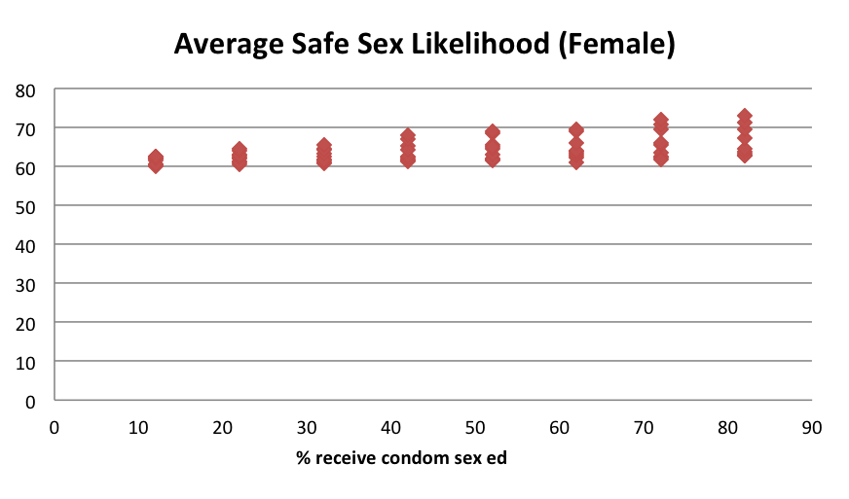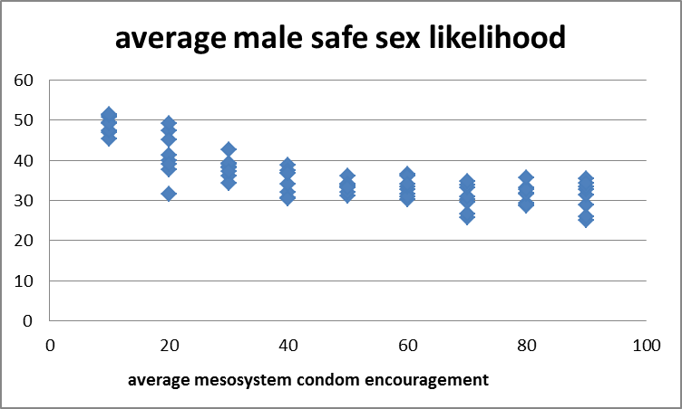
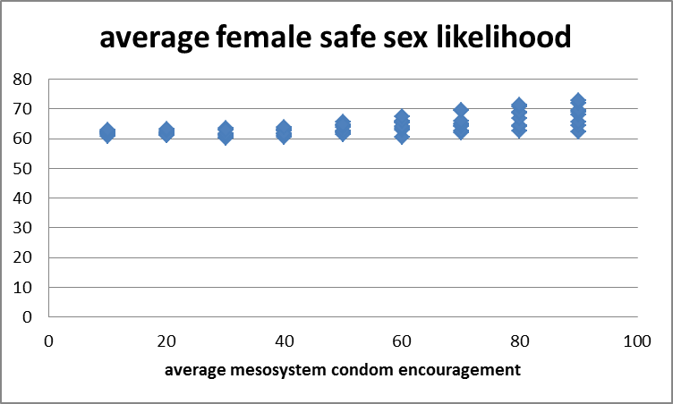

The second set of plots looks at the percent infected at the end of the average NetLogo runs as a function of both initial variables. It can be seen that there is a strong correlation of % infected with initial certainty. High certainty clearly leads to low final % infection rate. By contrast, there appears to be no correlation of % infection with initial justification. This suggests that despite any initial education on condom use, what ends up being critical is interaction with friends and “lessons learned” from interacting with those infected.

These patterns for % infected as a result of initial justification and initial certainty are matched for males. However, for females, there is little discernible impact of initial certainty on % infected. One wonders whether because the absolute infection level is so low for females (3 to 6%) compared to males (10 to 45%) that the impact of this variable cannot be picked up.
Based on the trends generated in this study, it appears that the most intriguing variable to minimize % infection would be to increase initial certainty in males. This perhaps highlights the role of parents in emotionally supporting their sons, perhaps more so than providing increasing educational information.

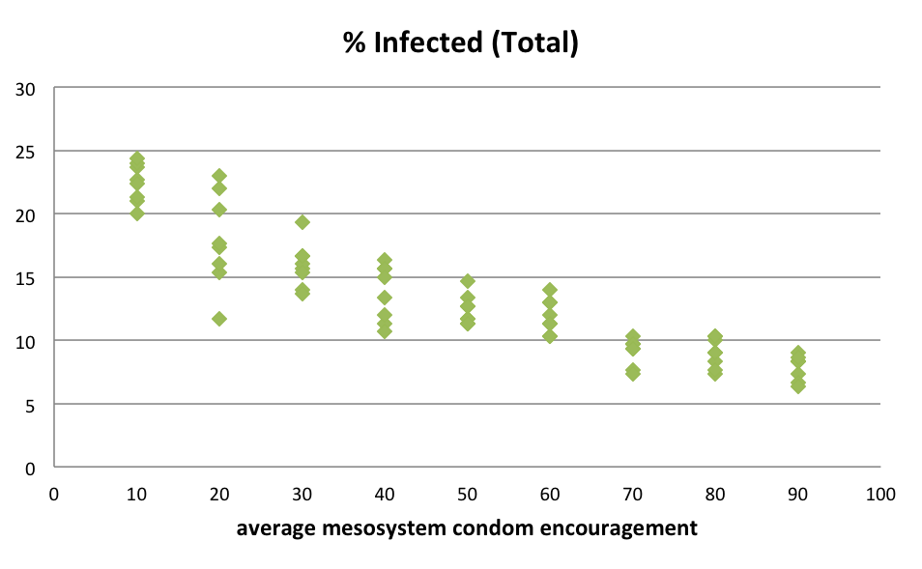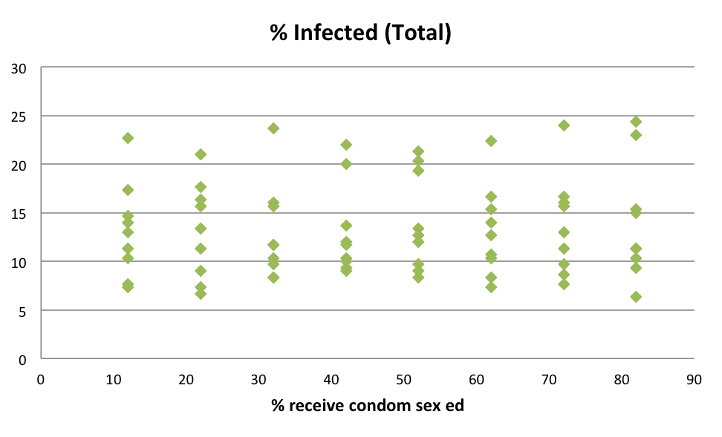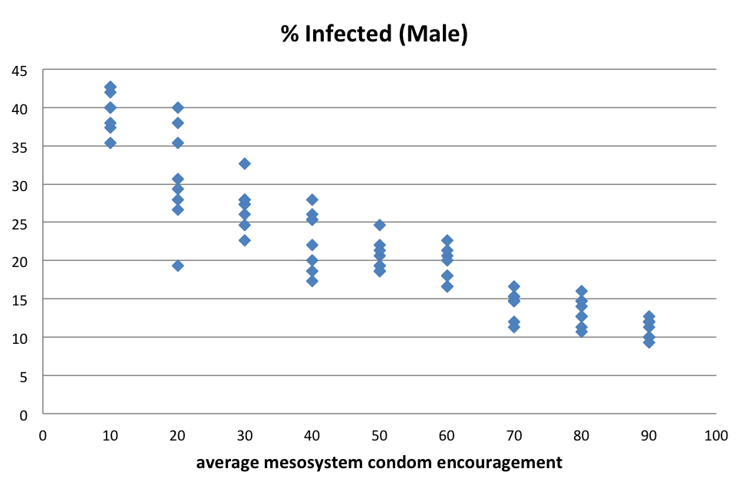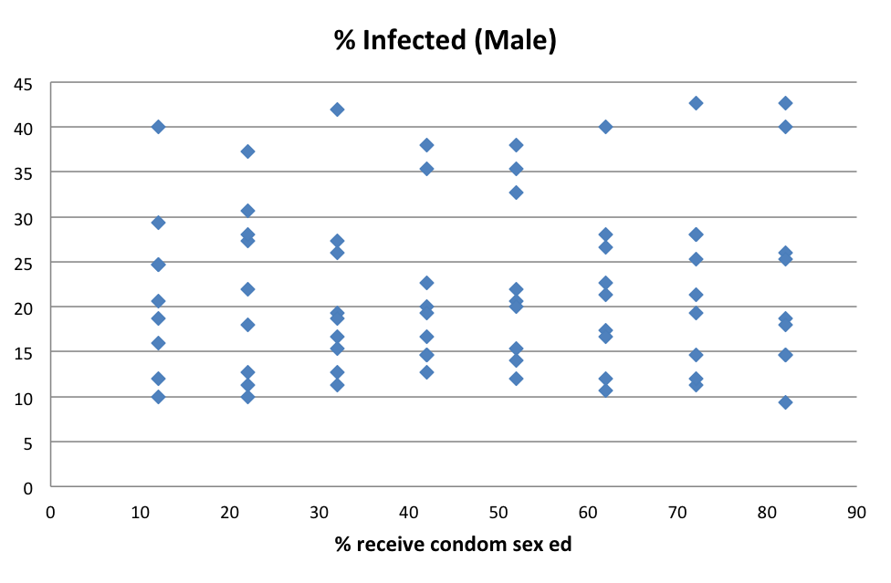

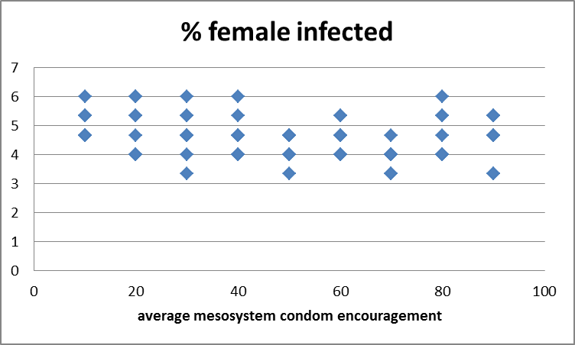
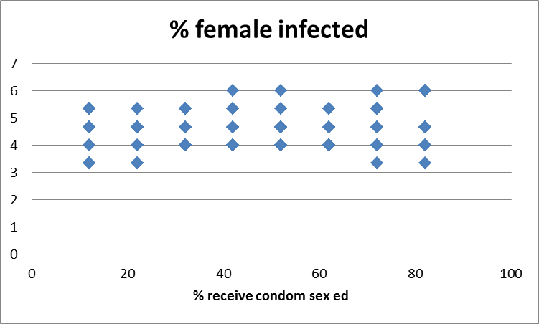

Model output
The model does a reasonable job of supporting the actual system behavior. Current infection rates among a population such as that modeled here is suggested in the literature to be about 40%. By contrast, the average infection rate over all the cases evaluated was about 15%. This suggests that perhaps some of the fixed assumptions (such as no malicious behavior or automatic use of condoms when symptomatic) could be challenged, were the model to be updated. However, the literature on this specific topic is quite sparse, perhaps because of the sensitive nature of the topic. One would like to see a more comprehensive study in the literature as a basis for comparison.
The strong negative correlation for males of percent infected with initial certainty perhaps can be rationalized to the work by Tormala and Rucker, which indicated the importance of firsthand experience in formulating attitude. Initial certainty could in this sense be viewed as secondhand experience and thus not so impactful on the final outcome. Differing responses between males and females on some of these variables suggests that there is some correlation between the variables that needs to be further explored.

Model Limitations
- The social network implementation is limited by the fixed network assumption. Since no friendships die (unless it became a sexual relationship), no social group membership changes, and no agent can be part of more than one social group, this will impact the model result.
- Different sexual behaviors (monogamy, abstinence) are prevalent in real life, but their contribution to likelihood or spread of infection is not known.
- Other forms of safe sex other than condoms may have different impacts. Certainly the assumption of 100% prevention rate for condom use (if used) may contribute to the lower infection rate for this data set than that observed in the literature.
- In practice, malicious behavior (unsafe sex when one knows one is infected) can be a major contributor to disease spread. Early spread of AIDS suggests that this variable might be important.
- The model is limited to the college age population. Although it may provide a reasonable model for that behavior, as a population ages, sexual frequency decreases and behavior may change due to other factors.
- The model assumes nothing about ethnicity. Ethnicity (among other variables such as economic class) may restrict coupling or pairing and thus isolate an STI to that subset. This limitation would manifest itself in the way the network was constructed. Perhaps an alternate network structure should have quite separate subnetworks with very little interaction. In that case, a global infection rate would have little meaning; only the infection rate within the subset would be meaningful.

Conclusions
Despite the limitations and the number of simplifying assumptions made, the lack of research specifically focused on attitudes surrounding safe sex make it difficult to determine if my model output is reasonably valid. The sensitive nature of the topic discourages scientific study of this topic and thus model validation.
This model suggests that intervention does seem to hold the most promise for reducing infection rates overall, most powerfully among males. Surprisingly, the focus suggested is not on improved education (justification) but rather improved values (certainty). The model reinforces that parents discuss (certainly with male children) that they need to take responsibility for their actions, and for their sexual health.

References
Centers for Disease Control and Prevention (2013). Gonorrhea - CDC Fact Sheet (Detailed Version). Retrieved from http://www.cdc.gov/std/gonorrhea/STDFact-gonorrhea-detailed.htm
Tormala, Z. L., & Rucker, D. D. (2007). Attitude Certainty: A Review of Past Findings and Emerging Perspectives. Social and Personality Psychology Compass, 1(1), 469–492. doi:10.1111/j.1751-9004.2007.00025.x

